Curriculum Vitae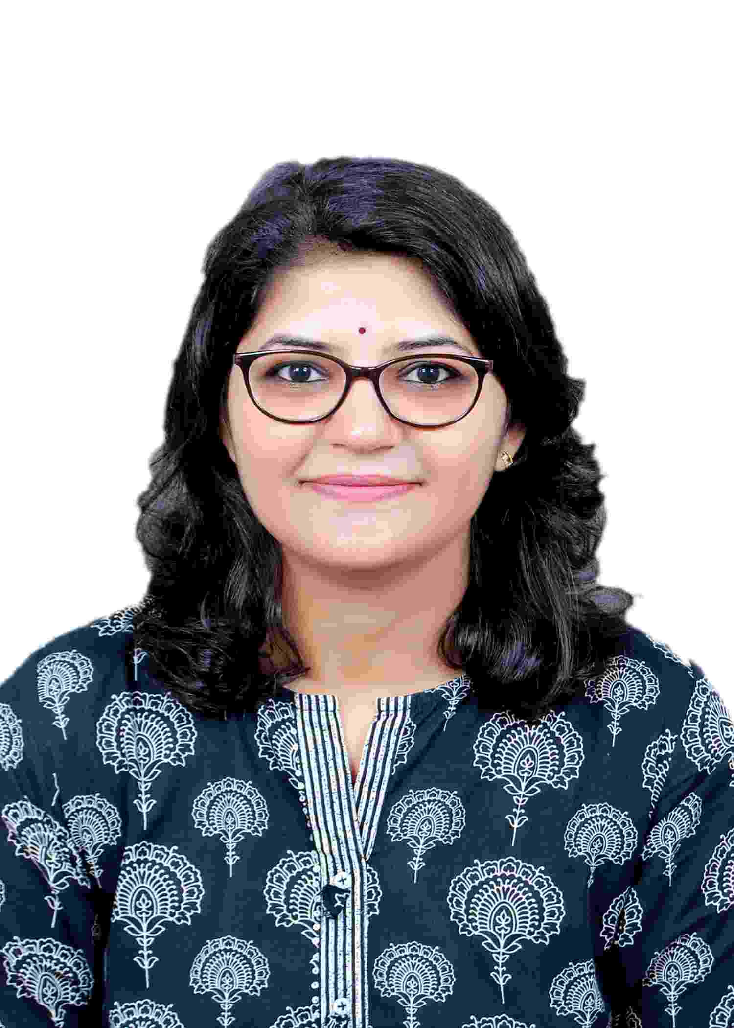

Name:- : DR. BHAMARE MUKTA RAJARAM
Assistant Professor
(M.Sc.Ph.D; NET;SET;B.Ed.)

Institutional Address:- Department of Botany, M.V.P Samjas, S.V.K.T Arts, Commerce And
Science College, Deolali Camp, Nashik.

Mail Id:- drmuktabhamare86@gmail.com or
bhamre.mukta@mvpsvktcollege.ac.in

Area of Interest: - Life sciences – Plant Biotechnology, Tissue Culture, Taxonomy, Cytogenetics and plant Breeding, Cell and Molecular Biology, Medicinal plant, Pharmacology, Plant Physiology, Plant Systematic, Environmental Science, Plant Ecology, Developmental Biology.

Awards and Achievement:-
- Received best “International Ayurveda Research Award-2014”
- Received best oral research paper presenter award 2020 at International Conference on ICCCBCE held on 28th – 29th Feb. 2020 held in Arts,. Commerce and B. N. S. Science College Soai, tal Newasa , Dist: Ahmednagar, Maharashtra, .
- Received Young Scientist Award for best oral research paper presenter at International Conference on “New trends in Science and Technology (NTSt-2021) held during 5Th - 6th August, 2021 organized by faculty of Science New , Arts, Commence and Science College, Parner, Dist. Ahmednagar, India.
- Received best oral research paper presenter award 2021 at International Conference on ICBBP held on 10^{h} – 12th Sept. 2021
- Received Young women Scientist Award at International Conference on innovation for sustainable bioresources and Bioeconom: challenges and practices (IBRSBB - 2024) “held at Sanjivani Arts, Commerce and Science college Kopargaon, Maharashtra (India) during 15Th - 16th February, 2024.
- NET examination secured all India 56 Rank examination held on Dec.2014.
- SET Examination Qualified Twice.
- SPPU PET in Botany examination 2013 secured 2nd rank.

Research and Teaching Experience: 12 years
Recognition as Ph.D Guide by Savitribai Phule Pune University Pune’
Sr.No | No. of research students Guided At P.G project | Ongoing Ph.D Research students
1 | 12 | 02

• Research: 12 years
• Teaching: 12 Years (Graduate and Post Graduate level)
Ph.D Research Topic:-
“In Vitro studies and Molecular characterization of Ceropegia species from Nashik District (M.S) India”

Patent On:- Storage Device to preserve and transport plant species (No.113186)

Experience and current status:-
No. | Designation | Name of the Institute / College | Course  Taught | Period of Service |  | Total Period
 |  |  |  | From | To
1 | Lecturer | G.E. Society’s H.P.T Arts & R.Y.K. Science College Nashik. | P.G & U.G Botany | 1/10/2010 | 23/08/2016 | 05 Years & 10 Months
2 | Assistant Professor  Non grant University Approved | MVP Samaj’s G.M. D Arts & B.W Commerce, Science college Sinnar. | U.G Botany | 24/08/2016 | 09/07/2019 | 03 years
3 | Lecturer | G.E. Society’s H.P.T Arts & R.Y.K. Science College Nashik. | Enviro.  Awareness | 01/12/2010 | 11/01/2013 | 06 Months
4. | Lecturer | MVP Samaj’s G.M. D Arts & B.W Commerce, Science college Sinnar. | M.Sc. Environmental science | 1/9/2018 | 09/07/2019 | 1 year
5. | Lecturer | MVP Samaj’s G.M. D Arts & B.W Commerce, Science college Sinnar. | B.Voc. Food technology | 1/9/2018 | 09/07/2019 | 1 year
6 | Assistant Professor | MVP Samajas K.T.H.M College Nashik. | P.G & U.G Botany | 10/7/2019 | 02/03/2022 | 2 years ,06 months
 | Assistant Professor | MVP Samajas K.S.K.W College , Cidco , Nashik. | P.G & U.G Botany | 3/3/2022 | 4/5/2023 | 14  months
 | Assistant professor | MVP Samajs S.V.K.T College Deolali Camp Nashik | U.G Botany | 5/5/2023 | Till date | 16 months

Membership and recognition of Academic Societies:
- Life member of Indian Botanical Society
- Life member of Indian Science Congress
- Member of Indian Association of Angiosperm taxonomy
- Recognition as Ph.D Guide by Savitribai Phule Pune University Pune’
Research papers: –
In International Journal:-
- “Phytochemical screening and antimicrobial activity of Sphaeranthus indicus (Astraceae) an ethnomedicinal plant.” (2014) International Journal of Pharmacy. ISJN: 8237-7516. (Number of authors: 03).
- “Phytochemical and Antimicrobial activity of Spilanthes acmella L.” (2015) World Journal of Pharmaceutical Research. Vol. (4) 4. 723-733. (Number of authors 02).
- “Phytochemical screening and antimicrobial potential of Kedrostris rostrata (Rottl.) Cong” (Curcurbiatceae).(2016) World Journal of Pharmaceutical Research. Vol. (5) 11. 1047-1055. (Number of authors 02).
- Floristic and cypsela diversity of Astraceae in Tryambakeshwar, Maharashtra, India (2017). Research Journey. Special issue 17.170-174.
- Ceropegias (Ceropegae:Apocynaceae) from Nashik District Maharshtra , India. Flora and Fauna 2017. Vol. 23 (I). Page No.(203- 207).
- Extended distribution of Ceropegia mahabalei Hemadri & Ansari (Apocynaceae) to the state of Gujarat, India. Journal of threatened taxa 26 Oct. 2019 I Vol.13 I Pages 14784 – 14786.
- Efficient plant regeneration and molecular marker - based genetic integrity analysis of Ceropegia lawii Hook: An endemic and endangered herb. Journal of applied biology and biotechnology Vol. 10 (01), pp. 95-102, January, 2022.
- Nutritional profiling of wild edible fruits of Meyna laxiflora Robyns (2022), International journal of Botanical studies. Vol 07 (02) , pp. 368-3.
- Ethnobotanical survey on folk medicinal plants of Igatpuri Tehsil, district Nasik, Maharashtra state (2022). International Journal of Botany Studies, Volume 7, Issue 2, Pages 362-367.
- Ethanomedicinal potential of Salher-Mulher forest Nashik district (Maharashtra). (2022)International Journal of Botany Studies, Volume 7, Issue 3, , Pages 68-71
- Preliminary phytochemical analysis and antimicrobial potential of Terminalia arjuna (Roxb) Wight & Arn. (2022). International Journal of Botany Studies, Volume 7, Issue 3, , Pages 136-14.
- Antibacterial Potential of Elicitor-treated Callus Cultures of Saptarangi (Salacia chinensis L.) Journal of Information & computational science Vol.12(08) ,114-125, 2022

Paper presented in International Conferences:-
- 6th International Conference on “Recent Trends in Life Sciences” (ICRTLS-2017) held in New Arts, Commerce and Science College Parner Dist. - Ahmednagar, Maharashtra, India “Ceropegias (ceropegieae:Apocynaceae) from Nashik District, Maharashtra, India.” for Oral presentation during 29th to 30th December 2017.
- International Symposium on ‘Teaching, Research And Innovative Approaches In Life Sciences’ 7 th & 8th Feb. 2018 (TRIALS 2018) held in S. N. Arts, D. J. M. Commerce and B. N. S. Science College Sangamner-422605, Dist: Ahmednagar, Maharashtra, India oral paper presented “In vitro regeneration and flowering of Ceropegia lawii Hook: an endemic and rare potential ornamental plant of Western Ghats”
- International Conference on “Recent advances in traditional medicinal plants & phytochemistry” 8 & 9 Feb. 2019 (ICRATMMPP 2019) held in Ahmednagar College, Dist: Ahmednagar, Maharashtra, India oral paper presented “In vitro multiplication and in vitro flowering of Ceropegia lawii Hook: an endemic medicinal plant of Western Ghats”
- International Conference on “Climate change and its effect on Biodiversity , Commerce & Economics” 28 & 29 Feb. 2020 (ICCCBCE 2020) held in Arts,. Commerce and B. N. S. Science College Soai, tal Newasa , Dist: Ahmednagar, Maharashtra, India oral paper presented “In vitro multiplication and molecular profiling of Ceropegia lawii Hook: an endemic and critically endangered plant of Western Ghats”
- International symposium on “New trends in Science and Technology (NTSt-2021) organized by faculty of Science New , Arts, Commence and Science College, Parner, Dist. Ahmednagar, India virtually held during 5Th - 6th August, 2021. Presentation of the research paper (Oral) entitled “Indirect shoot organogenesis and ISSR molecular marker analysis of Ceropegia lawii Hook.An endemic and critically endagered medicinal plant of western Ghats”.
- “31st annual Conference of Indian Association for Angiosperm Taxonomy and International Conference on “Documentation, Bioprospecting and Conservation of Biodiversity for Sustainable Development” to be held on 4th - 7th April, 2022 at Kalsubai-Harishchandragad Wildlife Sanctuary, Maharashtra. Presentation of the research paper (Oral) entitled“Highly efficient in vitro multiplication and genetic fidelity analysis of Ceropegia lawii Hook an endemic, threatened medicinal herb of Western Ghats.”
- Paper presented on topic “Indirect shoot organogenesis and ISSR molecular analysis of Ceropegia lawii Hoo.” in international conference on Recent advances in Animal Science on 1st Feb.2023 at The American College of Madurai, Tamilnadu.
Book Published:-
- T.Y.B.Sc Practical manual (Nirali Prakashan)
- Life Science NET/SET reference Book

Workshop attended/ participate
- Attended one day workshop for “AVISHKAR” on 12th August 2008.

- “Blotting Techniques” one day workshop, Institute of Life Sciences, H.P.T Arts & R.Y.K. Science College Nashik. On 12TH JAN -2009.
- “Advances in Genetics & Molecular Biology” State Level Seminar Organised by Department of Botany. H.P.T Arts & R.Y.K. Science College Nashik. On 30-31st JAN -2009.
- Participate In Science Popular Lecture Competition”- 2009 On 28th Feb. 2009. Conducted by H.P.T Arts & R.Y.K. Science College Nashik.
- Attended one day Training on Camag HPTLC System CAMAG organized by Switzerland recognized applications Research Lab, Mumbai.
- Participated 7th day workshop on “Science Communication Thought Digital Media” conducted by Vidyadeep foundation & H.P.T Arts & R.Y.K. Science College Nashik.
- Poster Presentation on “Phytochemical and Antimicrobial activity of Sphaeranthus indicus Linn” Conducted by 37th all India Conference of the Indian Botanical Society. At V.G.Vaze college Mulund (East) Mumbai. 7th – 9th Nov.2014.
- Attended 102nd Indian science congress, Univ. of Mumbai.Kalina campus Mumbai.3rd – 7th Jan 2015.
- Attended one day workshop on T.Y.B.Sc Practicals According New Syllabus, organized by the Department f Botany, Abasaheb Gaeware College, Pune,. Held on 5th Dec.2015.
- Attended National Conference on Recent Trends in Biodiversity, Conservation And Sustainable Development (RTBCSD-2016) at Karmveer Abasaheb Alis N.M. Sonawane Arts, Commerce & Science College, Satana.Feb.5-6th 2016.
- Attended three days workshop on research based application of quantitative techniques in social sciences, Conducted by department of economics & H.P.T Arts & R.Y.K. Science college Nashik. Held on 25th to 27 feb.2016.
- Attended and participation in two days international audit course under ISO 900:2015. Conducted by MVP Samaj’s G.M. D Arts & B.W Commerce, Science college Sinnar.
Held on 21st to 22 Nov.2017.
- Participation hands of training on Molecular biology at GKVK agricultural university Bangalore 5 June, 2018.

Orientation/Refresher/Faculty Development Programme:-
1. Successfully completed two week faculty development programme on Managing online classes and co creating MOOCs from May18 to 2 June 2020, conducted by Teaching learning center Ramanujan college university of Delhi.
2. Successfully completed one week faculty development programme on E – content development from May 1 to 5 may 2020, conducted by Computer science department Tuljaram Chaturchand college of Arts, Science & Commerece College Baramati Pune.
3. Successfully completed four week orientation programme from 4 June to 1 July 2020, conducted by Teaching learning center Ramanujan college university of Delhi.
Training Programme:-
- Participation hands of training on Molecular biology at GKVK agricultural university Bangalore 5 June to 10 June 2018.

Curricular and Co-curricular Activities:-
College:
- Worked as NAAC Assistant in G.M.D Arts & B.W. Commerce, Science College Sinnar.
- Criteria III (Research and consultancy) Head and member. Criteria VII, Member.
- Created 03 MoU and linkage, conducted various activities through and exchange the knowledge.
- Started T. Y. Botany as specialization at G.M.D Arts & B.W. Commerce, Science College Sinnar.
- Establishment and development of Medicinal plant Garden at Sinnar College.
- Convener and member of placement cell, soft skill programmed committee. Member RRC member of cultural programme of social gathering.
- Worked as coordinator for M.Sc. Environmental Science (YCMOU).
- Worked as coordinator for B.Voc. Food processing and food technology.
- Worked as coordinator for “Mahindra Pride” training programmed for all T.Y.BA/B.Com/B.Sc students in G.M.D Arts & B.W. Commerce, Science College Sinnar.
- Worked as organizer study tours for Botanical Excursion.
- Worked as Organizer for “Botany Fair’’for all students.
- Worked as organizer for “Green Day Celebration.”
- Worked as Organizer for Science Poster exhibition.
- Delivered lecturers on Biostatics at Trimbakeshwar College for T.Y.B.Sc Botany students
- Delivered lectures On Cryptogamic Botany at H.P.T. Arts & R.Y.K Science College Nashik.
- Delivered lectures On Environmental Education for M.A/M.Com/M.Sc. Students through YCMOU at Center H.P.T. Arts & R.Y.K Science College Nashik.
- Resource person at lecture on Plant Tissue culture under DBT star scheme at Sangamner Nagarpalika Arts, D.J.Malpani Commerce & B.N Sarda Science College Sangamner.
- Academic Counsellor at IGNO, Pune division.
- Academic Counsellor at YCMOU, Nashik.
- Developed medicinal plant nursery of native Indian forest plants species and 30 thousand plantlets were distributed to 10 Grampanchayat, schools and colleges, government offices, rotary clubs, Ashram schools free of coast.
- Organized “Chala Januya Vana” activity for all 200 S.Y.BA/B.Sc/B.Com students were participated to explored wild flora of Anjaneri hills near Tryambakeshwar.
- Worked as resource person in state level workshop on wine making at GARTI College, Nashik.
University level contribution:-
- As per University appointments worked as a Junior Supervisor in Colleges.
- As per University appointment worked on as Practical Examiner for UG and PG.
- As a Examiner for paper checking for UG and PG.
- As a Moderator for paper checking for UG & PG.
- Worked as paper setter and Examiner UG and PG
- Worked as T.Y.B.Sc. Syllabus framing
- Worked as one member committee for M.Sc Botany I and II year Lab Examination for allotment of PG Practical Exam center.
- Worked as senior supervisor internal as well as external
- AISHE nodal officer at college

